TEX-S

PRESENTED BY:

AMRINDER SINGH (CO20305)

The main aim of the project is to increase the typing speed of the user which has become a necessary requirement in this digital world.

The TEX-S is easy to use software designed to increase the typing speed of individual as it has become a necessity in today’s world. The software available online are costly and difficult to use and the free version of it doesn’t provide with proper facilities same as that of the paid version.

# SYSTEM ANALYSIS

## 2.1 EXISTING SYSTEM

Currently the system available doesn’t provide with as much benefits since most of them out there put much thought on the user typing speed as even a novice can get the work done even if takes longer time than required .

## 2.2 PROPOSED SYSTEM

### 2.2.1 SCOPE OF THE PROJECT

The main objective of the program is as follows:-

* To give user an estimate of its current typing speed.
* Provide them user friendly environment.
* Help them gradually increase their typing speed .

# AIM OF THE PROJECT

The objective of the project is to aim targeted audience that want to save their much precious time that is wasted on typing as their average speed is quite dissatisfying.

The average time that can be saved by a worker is up to 35 minutes per day which will compound as we move from days to week to months to years, saving a ton of time our which can be used in something productive.

# PROJECT MODULES

The project has been slashed into many small modules to run effectively, easy to understand and debug. Some important modules used in the project are:

Home Modules

Free Typing Modules

String Typing Modules

# MODULAR DESCRIPTION

**Home Module**

This module helps as follows:-

* This module gives the information about the different tabs that are being used in the program.
* The user can make use of this home module to know about the tabs which he or she has to make use.
* This module gives an overview of all other tabs.

**Free Typing Module**

This module helps as follows:-

* To practice free typing
* Consistency in typing , as color changes when there is a major change in typing speed
* The user can get instantaneous typing speed, average speed and time taken after completing the test.
* It is connected to main interface, where pressing ‘ESC’ to get final evaluations, pressing ‘ESC’ again to get to main interface.

**String Typing Module**

This module helps as follows:-

* User is asked to type a given string by the system.
* Helps check speed along with accuracy user gets score based on time taken and error.
* User can correct his/her mistake using backspace.
* It is also connected to main interface , ’ESC’ will help to get to main menu.

# SYSTEM IMPLEMENTATION

The program is been designed by making use of different modules and these modules help each other in the effective working of the program to give a specified result**.**

# RESULTS

1) MAIN MENU

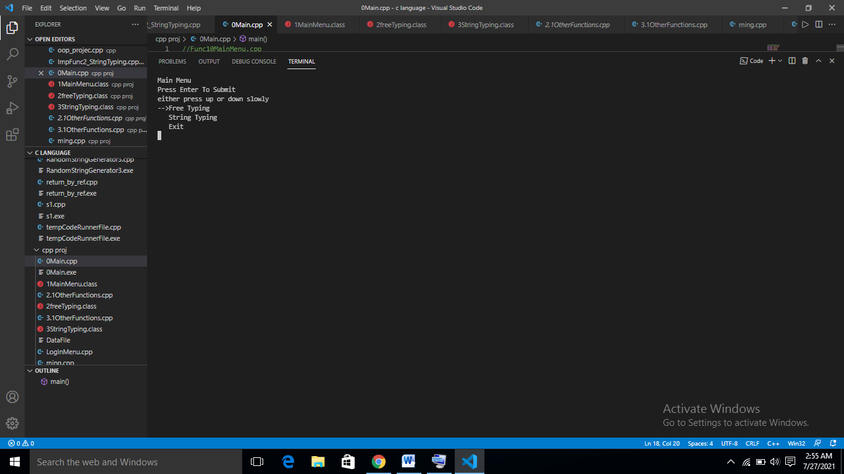

2) FREE TYPING INTERFACE

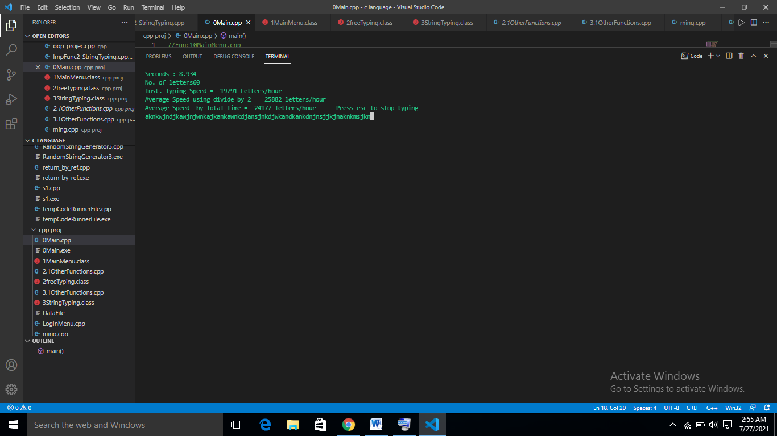

3) STRING TYPING INTERFACE (1)

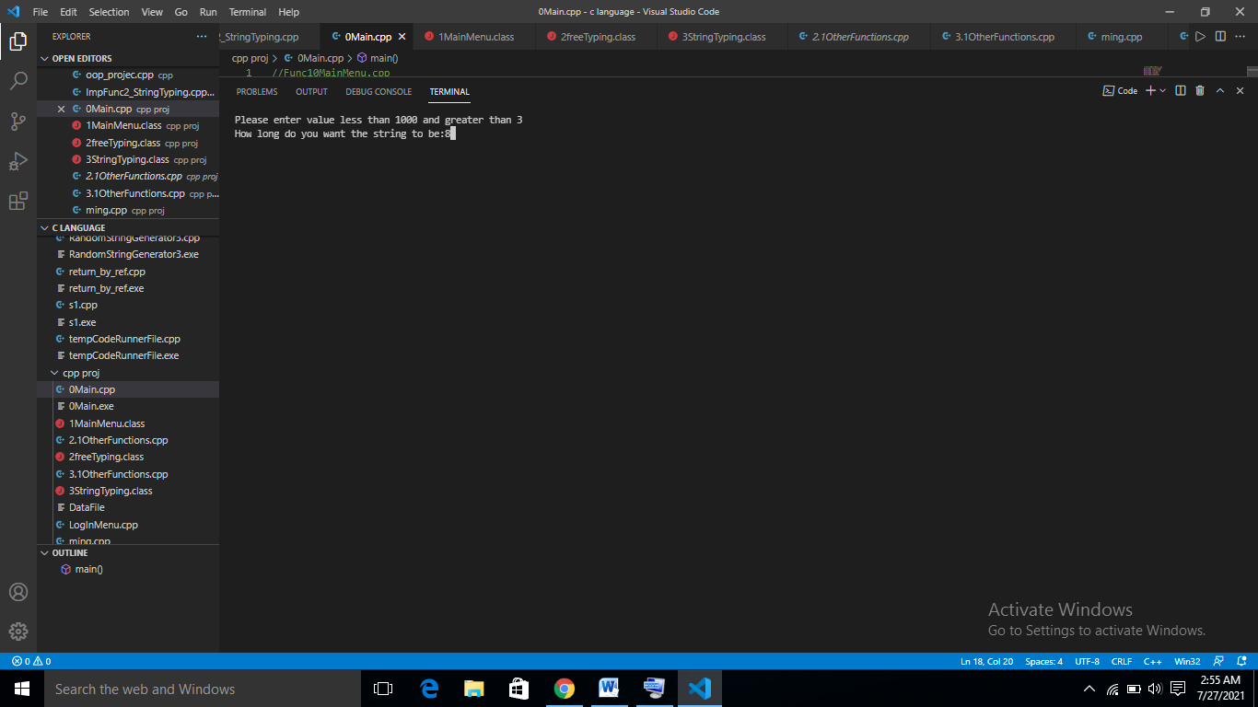

4) STRING TYPING INTERFACE (2)

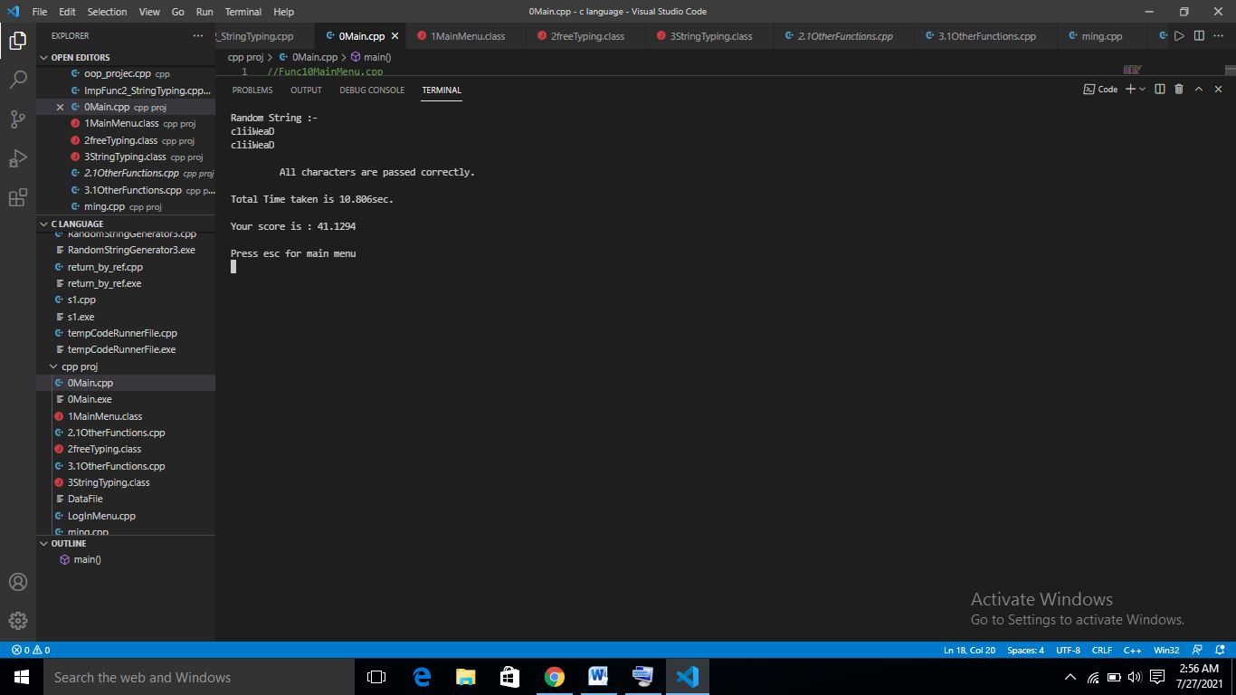

# 8. CONCLUSION

The result obtained is a complete package of program which is able to analyze the typing speed and accuracy and help in improving it.

# 9. REFERENCES

**1) GOOGLE**

**2) OBJECT ORIENTED PROGRAMMING BY E. BALAGURUSAMY**

**3) Robert Lafore - Object-oriented programming in C++**